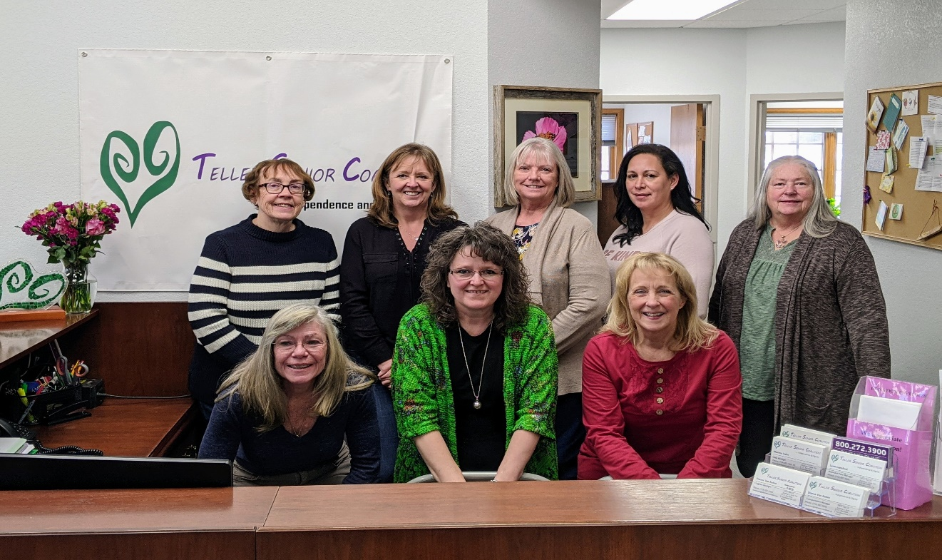

2021 Annual Report
TELLER SENIOR COALITION
• • • Independence
& Dignity

The Teller Senior Coalition (TSC) was created in 1996 to provide services to local seniors in the Teller County Region.

TSC believes all older adults should live with independence and dignity and stay in their homes as long as possible.

The many services we provide support this goal.

OUR MISSION
To provide services to Teller County senior citizens to enable them to live
healthy, active, and independent lives.

WELCOME

The Teller Senior Coalition had another successful year in 2021. We expanded our services plus continued to add new clients who needed assistance. We provided services to 1133 older adults in 2021, a 13% increase over 2020.

We support our mission by delivering meals and supplemental nutrition; providing transportation to medical appointments and for other essential services; making home safety modifications; assisting caregivers, and ensuring senior’s homes are clean with our homemaking services. We also provide senior food boxes to low- income seniors and help with heating needs.

Case management, the service that is the conduit to all of the services provided by TSC, saw an increase in monthly service hours as more seniors needed assistance due to the complex nature of available services. Our Case Managers help seniors navigate the aging process. They are dedicated to ensuring older adults receive the assistance they need from TSC and other agencies.

TSC had been looking for a larger office space to better serve older adults for the past four years. We found space in Divide, more centrally located in the county. We relocated in January 2022.

To our supportive Community, our grant partners, our dedicated volunteers, our hard-working TSC staff and our Board of Directors, I extend a heartfelt thank you for helping TSC continue to deliver exceptional services to older adults.

Katherine F. Lowry
Executive Director

OUR SERVICES

-

“Thank you very much, staff and Jake!” - TSC Client
“Thank you so very much for your kindness. You are the best.” – TSC Client
“I feel so lucky to be a part of such a wonderful organization.” – TSC Client
“We want to thank you from the bottom of our hearts for your kindness. Not only at the holidays but all the times you are always there for us.”– TSC Clients
“Dear wonderful people of the Coalition group. I am thanking you all for your amazing kindness throughout the year.” -TSC Client
Clients Served 1,133
Services Provided 18,669

Services
Transportation:
TSC provides our clients with transportation to essential services for seniors 60+ (medical appointments, shopping, banking and pharmacy). We provide transportation assistance for low income and disabled citizens, qualified Medicaid recipients, and the general public for a minimal fee. TSC provides a Public Shuttle on Wednesday.

Home Delivered Meals
TSC provides weekly delivery of frozen or shelf stable meals. We provide nutritional education and counseling.

Case Management:
Our Case Managers assess client’s needs, provides referrals and coordination of services to help them remain independent in their home. We call many of our vulnerable seniors to check on their well-being.
Caregiver Respite:
TSC provides a respite provider for caregivers which allows them a break from caregiving.

Handyman:
Our handyman services help seniors with minor home repairs and installation of safety devices such as grab bars.
Homemaker:
TSC provides light housekeeping, meal preparation,
laundry, etc. to ensure our client’s homes remain safe and healthy.
Energy Outreach:
Emergency assistance with heating and utility
costs.
Senior Food Boxes
Low income seniors are eligible for a monthly food box.
Service Impacts:
- 5,547 one-way trips
- 9,051 meals delivered
- 1,600 hours of respite care
- 1,417 hours of Case Management
- 120 hours of handyman service
- 1,530 hours of homemaker service
- $1196 dollars in emergency aid
- 752 emergency food bags delivered
- 159 senior food boxes

FINANCIALS 2021

REVENUE

Contributions $ 153,799
Program Services $ 491,612
Fundraising $ 13,887
Other $ 3,394

Total $ 662,692

EXPENSES

Program Services $ 574,403
Administrative $ 79,443
Fundraising/Misc $ 6,880

Total $ 660,726

BEHIND THE SCENES
Board Members – as of 12/31/2021
Carol Parks, President
Steve Frick, Vice President
Bob McCornack, Treasurer
Diann Pritchard, Secretary
Sherry Carr, Board Member
James Woodard, Board Member

Our new address as of January 2022:
11115 E. US Hwy 24, 2-D
P O Box 845
Divide, CO 80814-845
719-687-3330
www.tellerseniorcoalition.org

Katherine Lowry, Executive Director
Dianna Van Auken, Director of Transportation
Sharron Hahn, Director of Client Services
Lynn Lansford, Case Manager
Roni Gordon, Transportation Supervisor
Maggie Becker, Finance Administrator

OUR SUPPORTERS

Pikes Peak Area Council of Governments

23 Volunteers donated 2733 hours

A.V Hunter Trust
Anschutz Family Foundation
William & Betty Osborne Trust Fund
Colorado Department of Transportation Colorado Springs Osteopathic Foundation
TSC Board and Staff
Teller County
Myron Stratton
City of Woodland Park
El Pomar Foundation
Newmont Mines
Community Service Block Grant
Federal Emergency Management Agency
Pikes Peak Community Foundation
Hester and Edwin Giddings Foundation
U.C. Health Foundation
Tweeds Holiday Home Tour
Intermountain Rural Electric Association

