2019 Annual Report
TELLER SENIOR COALITION
• • • Independence
& Dignity

WHO WE ARE
Almost 25 years ago, Teller Senior Coalition (TSC) was created when Teller County decided to stop providing certain services to local seniors.

We believe all seniors should live with independence and dignity.

The services we provide support this goal.

OUR MISSION
To provide services to Teller County senior citizens to enable them to live
full, active, and independent lives.

WELCOME

I am pleased to announce 2019 was another exceptional year for Teller Senior Coalition. We were awarded a Best Marketing Organization from the Colorado Department of Transportation, and Marc Graham, TSC Driver, was named Transit Employee of the Year by Pikes Peak Area Council of Governments. We appreciate this recognition as we further our mission by continuing to deliver meals; provide transportation to medical appointments and for other essential services; make home safety modifications; assist caregivers, and ensure senior’s homes are clean with our homemaking services.

Also new is a Transit Van with a capacity for wheelchairs which was made available by funds from the Colorado Department of Transportation. We are grateful for their continued support since the demand for wheelchair transportation has increased significantly. We now transport 35 seniors in wheelchairs.

Case management, the service that is conduit to all of the services provided by TSC, saw an increase in monthly service hours to over 90 hours as more seniors needed assistance with the complex nature of available services. Our case managers are dedicated to ensuring our seniors receive the assistance they need from TSC and other County services.

To our supportive Community, our grant partners, our dedicated volunteers, our hard-working TSC staff and our Board of Directors, I extend a heartfelt thank you for making it possible to service more clients in 2019 than 2018. Teller Senior Coalition’s mission is for further growth in services in 2020, and expanding 2019 service options.

Katherine F. Lowry
Executive Director

OUR SERVICES

-
“TSC was a lifeline for me. Vital, good people doing amazing work. I had to move in early 2019, but I will never forget all they’ve done for me and others.”
- TSC Client
“Thank you so much for the service that you provide to the seniors of Teller County and their families.”
“You were a tremendous blessing to my husband and I in helping to provide great respite providers for my Mom.”
- TSC Client Caregiver

808
Clients Served

20913
Services Provided

Services
Transportation:

TSC provides our clients with transportation to essential services for seniors 60+ (medical appointments, shopping, banking and pharmacy). We provide transportation assistance for low income, disabled citizens, qualified Medicaid recipients, and the general public for a minimal fee. TSC provides a Public Shuttle on Wednesday and Friday.

Home Delivered Meals

TSC provides weekly delivery of frozen or shelf stable meals. We provide nutritional education and counseling.

Case Management:

Our Case Manager assesses client’s needs, provides referrals and coordination of services to help them remain independent in their home. We call many of our vulnerable seniors to check on their well-being.

Caregiver Respite:
TSC provides a respite provider for caregivers which allows them a break from caregiving.

Handyman:
Our handyman services help seniors with minor home repairs and installation of safety devices such as grab bars.
Homemaker:
TSC provides light housekeeping, meal preparation,
laundry, etc. to ensure our client’s homes remain safe and healthy.

Service Impacts:
- 7987 one-way trips
- 8853 Meals Delivered
- 2262 hours of Respite Care
- 1070 hours of Case Management
- 85 hours of Handyman service
- 1194 hours of Homemaker service
- $2,243 Dollars in emergency aid

FINANCIALS

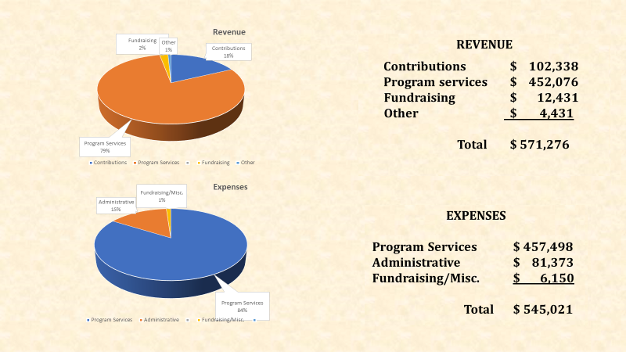

BEHIND THE SCENES
Board Members
Gail Gerig, President
Laura Meyers, Vice President
Bob McCornack, Treasurer
Margaret Ann McKinney, Secretary
Diann Pritchard, Board Member
Jeff Brandt, Board Member
Carol Parks, Board Member
Steve Frick, Board Member
*100% financial contribution
750 E. Highway 24, Bldg. 2
Suite 100,
P O Box 6956
Woodland Park, CO 80866
719-687-3330
www.tellerseniorcoalition.org

Katherine Lowry, Executive Director
Dianna Van Auken, RN Transportation Manager
Sharron Hahn, Case Manager
Lynn Lansford, Assistant Case Manager
Tanja Alday, Transportation Supervisor
Consuelo Whitman-Gruber, BS Program Assistant
Maggie Becker, Finance Administrator

OUR SUPPORTERS

Pikes Peak Area Council of Governments

20 Volunteers donated 2133 hours

A.V Hunter Trust
Cruise Above the Clouds
William & Betty Osborne Trust Fund
Colorado Department of Transportation Colorado Springs Osteopathic Foundation
Easter Seals Colorado
TSC Board and Staff
Teller County
Myron Stratton
City of Woodland Park
Community of Caring
T. Rowe Price
El Pomar Foundation
Newmont Mines
Next 50 Initiative

